**DAILY ONLINE ACTIVITIES SUMMARY**

|  |  |  |  |  |  |  |  |  |
| --- | --- | --- | --- | --- | --- | --- | --- | --- |
| **Date:** | **30-06-2020** | | | | | **Name:** | **Deeksha D Poojary** | |
| **Sem & Sec** | **VIII Semester & A Section** | | | | | **USN:** | **4AL16CS026** | |
| **Online Test Summary** | | | | | | | | |
| **Subject** | | **-** | | | | | | |
| **Max. Marks** | | **-** | | **Score** | | | **-** | |
| **Certification Course Summary** | | | | | | | | |
| **Course** | **Introduction to Amazon Elastic Compute Cloud (EC2)** | | | | | | | |
| **Certificate Provider** | | | **Amazon Web Service** | | **Duration** | | | **10 minutes** |
| **Coding Challenges** | | | | | | | | |
| **Problem Statement: Write a program to find number of days in a year** | | | | | | | | |
| **Status: COMPLETED** | | | | | | | | |
| **Uploaded the report in Github** | | | | | **YES** | | | |
| **If yes Repository name** | | | | | **deekshapoojari** | | | |
| **Uploaded the report in slack** | | | | | **YES** | | | |

Online Test Details:

NIL

Certification Course 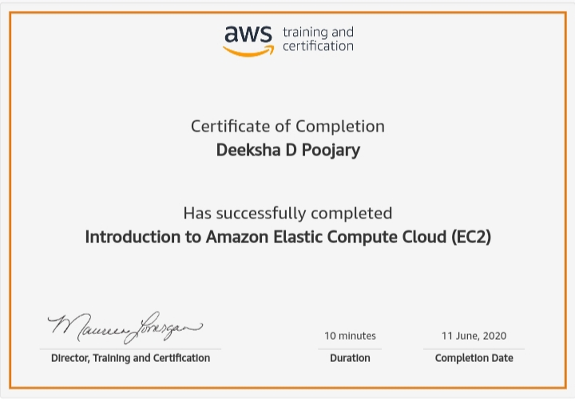Coding Challenges Details:

|  |
| --- |
|  |
|  |
|  |
|  |
|  |
|  |
|  |
|  |
|  |
|  |
|  |
|  |
|  |
|  |
|  |
|  |
|  |
|  |
|  |
|  |
|  |
|  |
|  |
|  |
|  |
|  |
|  |
|  |
|  |
|  |
|  |
|  |
|  |
|  |
|  |
|  |
|  |
|  |
|  |
|  |
|  |
|  |
|  |
|  |
|  |
|  |
|  |
|  |
|  |
|  |
|  |
|  |
|  |
|  |

**Program1:**

|  |  |
| --- | --- |
|  |  |

**#include<stdio.h>**

**int main()**

**{**

**int year, month;**

**printf("Enter the month number and year: ");**

**scanf("%d %d",&month,&year);**

**if(month == 1 || month == 3 || month == 5 || month == 7 || month == 8 || month == 10 || month == 12)**

**printf("Number of days is 31\n");**

**else if((month == 2) && ((year%400==0) || (year%4==0 && year%100!=0)))**

**{**

**printf("Number of days is 29\n");**

**}**

**else if(month == 2)**

**{**

**printf("Number of days is 28\n");**

**}**

**else**

**printf("Number of days is 30\n");**

**return 0;**

**}**